City of Highland Village: Succession Planning Report

JKM Consulting

Jacqueline Beltran, Kishan Belakkal, and Mrunalinee Desai

The University of Texas at Arlington

Dr. Charles Newson

2262-MANA-5334-001
Table of Contents
2. Project Background 3
3. Scope of Work and Objectives 3
4. Project Phases 4
5. Methodology 4
6. Key Assumptions and Adjustments 5
7. Project Deliverables 5
8. Detailed Project Schedule 5
9. Roles and Responsibilities 5
10. Risk Considerations 5
11. Quality Assurance 6
12. Data Collection & Validation 6
13. Project Timeline 6
14. Workforce Risk Assessment (Quantitative Analysis) 7
15. Leadership Pipeline & Succession Readiness (Qualitative Analysis) 7
16. Training & Certification Requirements 8
17. Identified Gaps & Recommendations 9
References 12

1. Executive Summary
This project focuses on succession planning in the City of Highland Village’s Fire Department and Parks and Recreation Department. The goal is to understand how prepared the City is to replace employees in key roles, especially leadership positions, and to identify any gaps that could create risk in the future.
After reviewing workforce data, job descriptions, certification requirements, and external research, it became clear that the City does have employees who could move into higher roles. However, most of them are not ready right now. Many are still working through certifications, completing required training, or gaining the experience needed to take on leadership responsibilities. Because of this, there is a clear gap between having potential successors and having employees who are actually ready to step in immediately.
At the same time, external data shows that the City cannot rely on hiring alone to solve this issue. Highland Village has a population of about 16,149 and is already mostly developed, which limits long-term growth (U.S. Census Bureau, n.d.). Compared to nearby cities like Lewisville and Denton, which have significantly larger populations, Highland Village has a smaller workforce pool to draw from (U.S. Census Bureau, n.d.).

In addition, the demand for fire and emergency service workers is high across the country. The Bureau of Labor Statistics reports about 27,000 firefighter openings and 19,000 EMT and paramedic openings each year (Bureau of Labor Statistics, 2024). This makes it more difficult for smaller cities like Highland Village to compete for experienced workers. Overall, the main issue is not a lack of employees, but a lack of readiness at the right time. Employees are moving through the system, but not enough are fully prepared at the same time, which creates risk if key positions become vacant.

2. Project Background
The City of Highland Village is working to improve its succession planning efforts to prepare for future workforce changes, including retirements and turnover. In both the Fire Department and Parks and Recreation Department, many roles require specialized training, certifications, and experience. Because of this, replacing employees is not a quick process.

This project focuses on understanding how employees move through each department and where gaps exist in the process. It also looks at how knowledge and experience can be passed on over time so the City does not lose important skills when employees leave.
Research shows that many organizations, especially in local government, struggle with succession planning because they do not begin preparing employees early enough. Instead, they wait until a position becomes vacant, which creates gaps in leadership and operations . This project helps identify where those same challenges exist in Highland Village.

3. Scope of Work and Objectives
JKM Consulting reviewed workforce data, job descriptions, certification requirements, and succession planning spreadsheets from both departments. This information was used to map out career pathways and understand how employees move from entry-level roles into leadership positions.

External data was also included to provide context. Census data helped explain population size, growth, and workforce limitations. Labor data from the Bureau of Labor Statistics helped explain how competitive hiring is for certain roles, especially in fire and emergency services.

The main objective was not just to identify possible successors, but to understand whether they are actually ready based on training, certifications, and experience. This is important because having a potential successor does not mean they can step into the role immediately.
Key Goals:
- Analyze workforce demographics, including census data.
- Confirm certification requirements.
- Map out promotion pathways.
- Identify employees who can pursue certifications.
- Recommend training and development programs to improve morale and retention in the Fire department.
- Suggest cross-functional training as a more affordable option.

4. Project Phases
The project is divided into three phases:
- Discover: Collect workforce data and job descriptions.
- Define: Review promotion patterns, experience levels, and certification needs.
- Deliver: Present the final succession planning framework and results.

5. Methodology
The analysis was based on both internal and external data. Internally, workforce spreadsheets were used to evaluate employee readiness, years of experience, and identified successors. Job descriptions were reviewed to understand the responsibilities of each role. Task books were also reviewed, especially in the Fire Department, to understand the exact requirements employees must complete before being promoted.

These task books are important because they require employees to demonstrate real-world skills, not just complete training. For example, employees must show they can handle emergency situations, operate equipment, and lead others before they are considered ready for advancement.

External research was used to support the findings. Studies show that effective succession planning involves building a pipeline of employees over time, rather than relying on a single replacement. This helps explain why having only one possible successor creates risk.

6. Key Assumptions and Adjustments
The project first assumed that hiring would be internal, certifications would be easy to access, promotions would mainly depend on certifications, and experience would be the main factor. However, the findings showed:
- External hiring is sometimes needed to fill gaps.
- Certification costs can limit access, and lack of certification limits promotion.
- Experience and performance also matter, especially for the Fire Dept.
- Language barriers in Parks & Recreation can create communication challenges.

7. Project Deliverables
- Workforce Analysis Spreadsheets: Show employee readiness.
- Career Pathway Documentation: Outline growth paths for both departments.
- Succession Planning Framework: Identify leadership pipelines.
- Final Project Report and Presentation: Summarize findings and recommendations.

8. Detailed Project Schedule
- Feb 16: Kickoff and Scope Confirmation.
- Mar 3: Receive Workforce Data.
- March: Draft SOW, Site Visits, Data Analysis, Literature Review.
- Apr 6: Final Report Template.
- Apr 14: Succession Planning Framework.
- Apr 27: Final Presentation.

9. Roles and Responsibilities
City of Highland Village (COHV):
- Kimberly Lopez: Main contact for data and coordination.
- Fire & Parks stakeholders: Provide technical input and validation.
JKM Consulting (Part-time allocation):
- Mrunalinee Desai: Project oversight and presentations.
- Jacqueline Beltran: Data analysis and report writing.
- Kishan Belakkal: Visual design and quality review.

10. Risk Considerations
One of the most important parts of this project is understanding the risk of roles becoming vacant and the impact those vacancies would have. In the Fire Department, the impact of a vacancy increases significantly at higher levels. For example, if a Firefighter/Paramedic leaves, other employees can help cover shifts temporarily. However, if a Captain or Assistant Fire Chief position becomes vacant, it can affect decision-making, emergency response coordination, and overall safety. The risk is also higher at these levels because fewer employees are qualified to fill the role. Employees must complete multiple certifications, task books, and leadership training before they are eligible. This means the City cannot quickly replace someone in a leadership position.

In Parks and Recreation, the risk and impact vary depending on the role. Entry-level positions may have higher turnover, but they are easier to replace. However, specialized roles, such as irrigation or pesticide-related positions, have a higher impact if vacant because they require specific certifications and skills. Overall, the combination of high risk and high impact is most concerning leadership and specialized roles.

11. Quality Assurance
The consulting team reviews all work to ensure accuracy and consistency. Workforce data is checked against job descriptions and certification requirements. Drafts are reviewed internally before being shared with the City for feedback.

12. Data Collection & Validation
The workforce data shows that risk is not evenly distributed across roles. Instead, it increases as roles become more specialized or move higher in the organization.
In the Fire Department, entry-level roles have lower risk because there are multiple employees in those positions. However, at the Driver/Operator and Captain levels, the number of qualified employees decreases. This creates a situation where even one vacancy can have a noticeable impact on operations. In addition, some employees are approaching retirement eligibility, which increases the likelihood that certain roles may become vacant in the near future. When this is combined with the time required to train replacements, it creates a higher level of concern.

In Parks and Recreation, the risk is more tied to specialization. Some roles require certifications that only a few employees have. If one of those employees leaves, the City may not have anyone immediately available to take over. Another important part of the analysis is understanding the relationship between “risk if vacant” and “impact if vacant.” Some roles may not be likely to become vacant, but if they do, the consequences are serious. This is especially true for leadership roles, where decisions affect the entire department.

13. Project Timeline

Date | Milestone | Description
Feb 16 | Kickoff & Scope | Confirmation and planning.
Mar 3 | Data Receipt | Workforce data provided.
March | Analysis Phase | SOW draft, site visits, data review, and literature.
Apr 6 | Report Template | Final report structure development.
Apr 14 | Framework Finalized | Succession planning strategy complete.
Apr 27 | Final Presentation | Delivery of findings and recommendations.

14. Workforce Risk Assessment (Quantitative Analysis)
The quantitative data helps show why succession planning is a concern for the City of Highland Village. This includes population data, service demand, financial resources, and workforce availability. First, population data shows that Highland Village has about 16,149 residents, which is much smaller than nearby cities like Lewisville and Denton (U.S. Census Bureau, n.d.). This smaller population means the City has a more limited workforce pool and fewer internal candidates to develop over time. In addition, about 16–17% of the population is age 65 or older (U.S. Census Bureau, n.d.). This is important because it may increase demand for emergency medical services and community programs in the future. As demand increases, the need for experienced employees also increases. Fire Department data also shows consistent service demand. The department responds to around 1,700+ calls per year, which averages about 4–5 calls per day (City of Highland Village, n.d.). This means the department cannot afford staffing gaps, especially in leadership roles that coordinate emergency responses.

At the same time, labor market data from the Bureau of Labor Statistics shows that there is strong competition for these roles. There are about 27,000 firefighter openings and 19,000 EMT and paramedic openings each year (Bureau of Labor Statistics, 2024). This makes it more difficult for Highland Village to hire experienced employees from outside.
Financial data also provides important context. The Fire Department has a budget of about $4.4 million, while Parks and Recreation has about $2.6 million (City of Highland Village, 2023). These budgets show that both departments are major parts of City operations, and any staffing gaps could directly affect services.

In Parks and Recreation, the department manages over 335 acres of parkland, 19 parks, and 23.6 miles of trails (City of Highland Village, n.d.). This level of responsibility requires consistent staffing and leadership, especially in supervisory roles.
When combining all of this data, the main takeaway is that:
- The City has limited population growth and workforce expansion
- Service demand is steady and cannot decrease
- Hiring is competitive and not always reliable
- Departments manage large operations with limited staff
Because of this, the City cannot depend on external hiring to fill gaps. Instead, it must rely on internal development, which takes time. This is why succession planning is critical.

15. Leadership Pipeline & Succession Readiness (Qualitative Analysis)
The qualitative data provides a clearer picture of how employees move through each department and why there are gaps in succession planning. While the quantitative data shows numbers and trends, the qualitative portion explains what is actually happening within the workforce. In both the Fire Department and Parks and Recreation Department, there is a clear pipeline for advancement. Employees generally start in entry-level roles and move up into more advanced and leadership positions over time. However, the data shows that as employees move higher in the organization, the number of qualified candidates becomes smaller. This creates a narrowing pipeline, especially at leadership levels.

In the Fire Department, the pipeline is very structured and heavily based on training and performance. Employees begin as Firefighter/Paramedics and move up to Driver/Operator, then Captain, and eventually into higher leadership roles. Each step in this process requires employees to complete specific task books, earn certifications, and demonstrate their ability to handle both technical and leadership responsibilities.
One important pattern seen in the data is that many employees are identified as “developing” rather than “ready now.” This means they have the potential to move into higher roles, but they have not yet completed all requirements. For example, an employee may have strong experience but still need to finish a task book or earn a certification before becoming eligible for promotion. Another key issue in the Fire Department is the presence of bottlenecks. The Driver/Operator and Captain levels act as major transition points. These roles require a shift from mainly technical work to leadership and decision-making. Because of this, fewer employees are able to successfully move past these stages. This creates a situation where there are multiple employees at the lower levels, but very few at the higher levels.

In the Parks and Recreation Department, the pipeline is less structured but still shows similar challenges. Employees typically start in Technician roles and move up to Crew Leader or Supervisor positions, and then into leadership roles such as Superintendent or Director. One difference in this department is that there are multiple career paths, including operations and recreation programming. This means employees may develop different types of skills depending on their role. However, leadership positions require a combination of technical knowledge, administrative skills, and experience managing people. This makes it more difficult for employees to become fully prepared for these roles. The data also shows that some positions in Parks and Recreation have only one identified successor, or in some cases none at all. This creates a risk because if that employee is not ready or leaves the organization, there is no backup plan.

Another important finding across both departments is the gap between potential and readiness. Many employees are capable of moving up in the future, but they are not ready at the same time. This creates a timing issue, where the pipeline exists but does not align with when positions become vacant. This timing issue is one of the biggest challenges in succession planning. If an employee in a leadership role leaves unexpectedly, the City may not have anyone who is fully prepared to replace them immediately. Even if there are strong candidates, they may still need additional time to complete training or gain experience. Overall, the qualitative analysis shows that the City has a solid foundation for succession planning, but the pipeline becomes weaker at higher levels. The combination of training requirements, leadership expectations, and limited number of qualified candidates creates gaps that need to be addressed.

16. Training & Certification Requirements
Training and certification requirements are one of the biggest reasons why employees are not immediately ready for promotion. These requirements are not just formalities. They are designed to make sure employees are fully prepared before taking on higher responsibilities.
Fire Department:
In the Fire Department, the training process is very structured and detailed. Employees must complete something called task books, which are step-by-step guides that list all the skills and experiences they need to demonstrate before moving to the next role.
For example, to move from Firefighter/Paramedic to Driver/Operator, employees must:
- Complete multiple phases of task books
- Show they can safely operate fire apparatus
- Demonstrate knowledge of emergency response procedures
- Be evaluated by supervisors
This is not something that can be completed quickly. Employees must gain real experience over time and prove that they can perform under pressure.
To move from Driver/Operator to Captain, the requirements become even more advanced. Employees must:
- Complete higher-level task books
- Earn certifications such as Fire Officer and Fire Instructor
- Demonstrate leadership ability during real incidents
- Pass formal evaluations, including written and practical assessments
These steps are important because Captains are responsible for making decisions during emergencies. The City cannot risk promoting someone who is not fully prepared.
Parks and Recreation:
In the Parks and Recreation Department, the training process is less structured but still requires time and experience.
Some roles require technical certifications, such as:
- Irrigation licenses
- Pesticide application licenses
These certifications are important because they involve safety and regulatory requirements. Employees must understand how to properly manage systems and follow state guidelines.
In addition to technical certifications, employees must also develop administrative and leadership skills, such as:
- Budget management
- Project planning
- Staff supervision
- Communication with the public
These skills are usually learned through experience rather than formal training, which means they take time to develop.
Because of this, training and certification timelines create a major challenge for succession planning. Even when employees are interested in moving up, they may not be able to meet all requirements right away. This explains why many employees are in the “developing” stage instead of being “ready now.” It is not that they lack ability, but that they are still completing the steps needed to qualify.

17. Identified Gaps & Recommendations
The data shows areas where there are not enough internal candidates, especially in certain pathways like Recreation. Recommendations focus on training and development to strengthen these areas and improve the overall talent pipeline.

Fire Department
- Internal development of successors is a cost-effective and sustainable long-term strategy that ensures continuity in specialized roles.
- External hiring may be required to fill gaps quickly, but dependency on external hiring could be minimized wherever possible, especially roles below Assistant Fire Chief.
- There is a risk of short-term gaps if transitions are not planned early.
- Provide training and exposure to the team across various catastrophic situations, such as wildfires and natural disasters, to motivate and keep them engaged.
- If there are limitations in sponsoring paid certifications or training, identify the most reliable and high-performing candidates and require them to complete mandatory training within a defined timeline, while clearly communicating thefuture benefits of the program.
- Consider sending selected team members to nearby counties like Dallas or other busy cities for exposure to emergencies they have not handled before, possibly on a quarterly exchange basis.
- Also, bring in personnel from other counties to learn and share how fire departments operate across Highland Village.

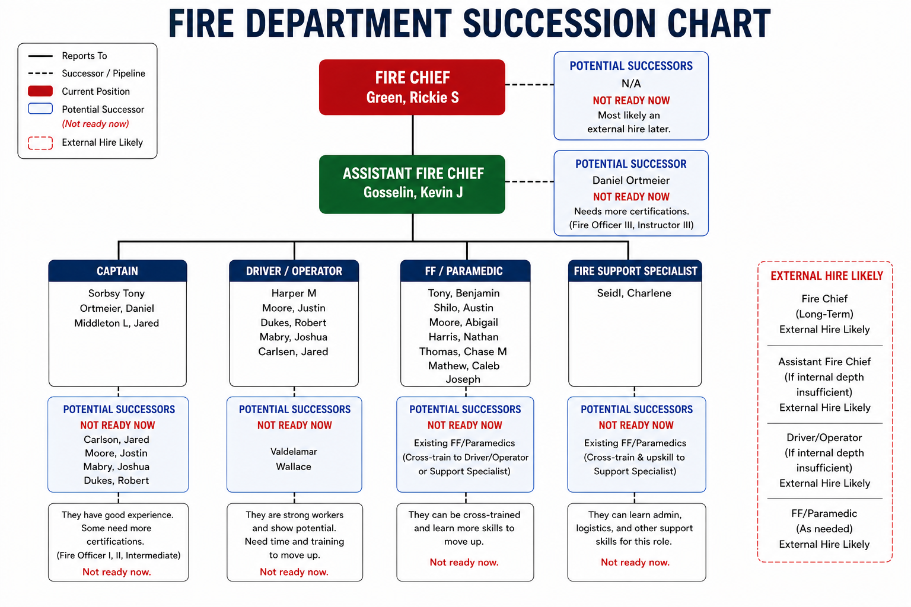
Parks and Recreation Department
- Introducing potential future eligible successors to higher roles like shadowing and cross training so that they would feel more interested and involved.
- If there are limitations in sponsoring paid certifications or training, identify the most reliable and high-performing candidates and require them to complete mandatory training within a defined timeline, while clearly communicating the future benefits of the program.
- There is a risk of short-term gaps if transitions are not planned early. Internal development of successors is a cost-effective and sustainable long-term strategy that ensures continuity in specialized roles.
- External hiring may be required to fill gaps quickly, but dependency on external hiring could be minimized wherever possible, especially roles below Assistant Director.

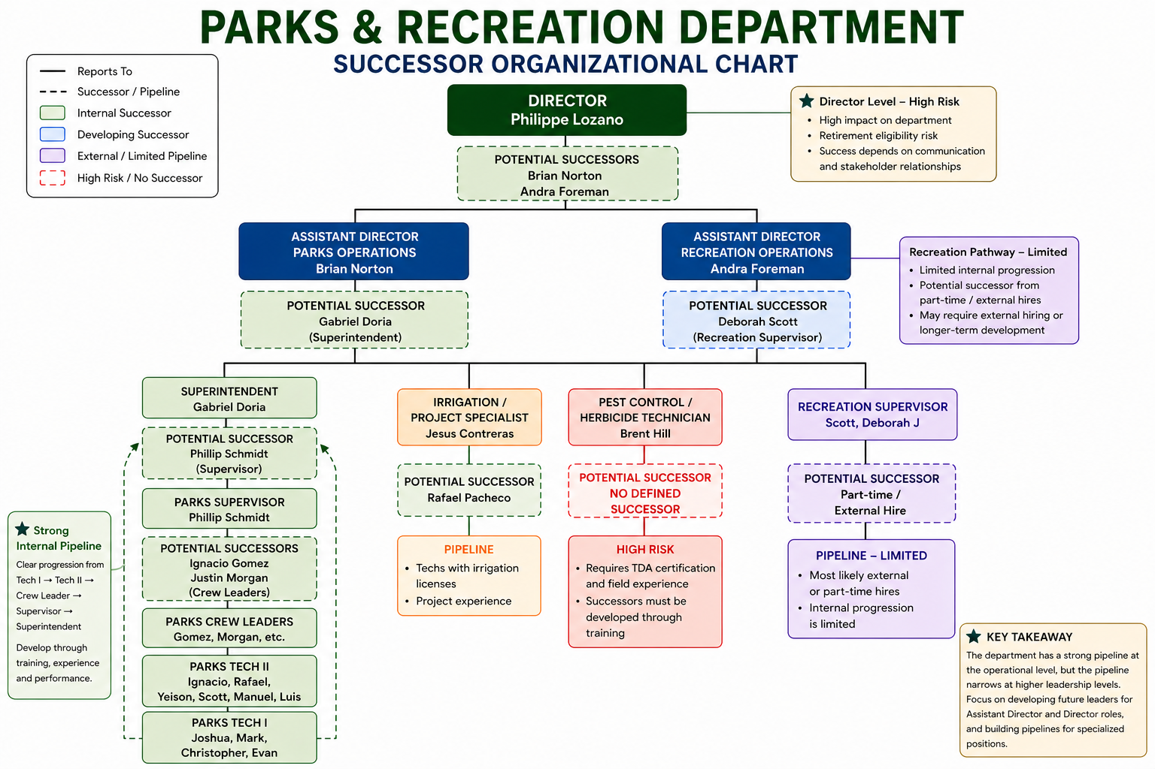

References
Bureau of Labor Statistics. (2024a). Firefighters.
https://www.bls.gov/ooh/protective-service/firefighters.htm
Bureau of Labor Statistics. (2024b). EMTs and paramedics.
https://www.bls.gov/ooh/healthcare/emts-and-paramedics.htm
City of Highland Village. (2023). Annual comprehensive financial report.
https://www.highlandvillage.org/ArchiveCenter/ViewFile/Item/4571
City of Highland Village. (n.d.-a). Fire department incident statistics.
https://www.highlandvillage.org/817/Fire-Department-Incident-Stats
City of Highland Village. (n.d.-b). Fire and EMS operations.
https://www.highlandvillage.org/814/Fire-and-EMS-Operations
City of Highland Village. (n.d.-c). Parks department overview.
https://www.highlandvillage.org/149/Parks
City of Highland Village. (n.d.-d). Recruitment.
https://www.highlandvillage.org/820/Recruitment
Community Impact. (2021, October 13). Review recommends more firefighters in Highland Village, where ISO rating could drop one level.
https://communityimpact.com/dallas-fort-worth/lewisville-flower-mound-highland-village/public-safety/2021/10/13/review-recommends-more-firefighters-in-highland-village-where-iso-rating-to-drop-one-level/
Leland, S.M., Carman, J.G. and Swartz, N.J. (2012), Understanding managerial succession planning at the local level: A study of the opportunities and challenges facing cities and counties. Nat Civic Rev, 101: 44-50. https://doi.org/10.1002/ncr.21076
Smalls, L. W. (2022). Succession Planning: Strategies HR Managers Use to Fill Key Leadership Positions. Walden University. https://scholarworks.waldenu.edu/dissertations/13780U.S. Census Bureau. (n.d.-a). QuickFacts: Highland Village city, Texas.
https://www.census.gov/quickfacts/fact/table/highlandvillagecitytexas/LND110210
U.S. Census Bureau. (n.d.-b). QuickFacts: Lewisville city, Texas.
https://www.census.gov/quickfacts/fact/table/lewisvillecitytexas/PST045224
U.S. Census Bureau. (n.d.-c). QuickFacts: Denton city, Texas.
https://www.census.gov/quickfacts/fact/table/dentoncitytexas/LND110210

